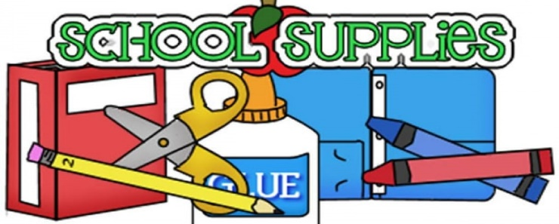

**Folger McKinsey Elementary School**

**Student School Supplies 2023-24**

**All students need:**

(1) book bag (no wheels; large enough to carry projects/folders) ​

(1) lunch box (that fits lockers 4 ½” x 8” x 10”)

(1) headphones (in bag with name)

All other basic materials for classroom use, such as pencils, crayons, markers, and folders, will be provided by the school system. Families are encouraged to replenish supplies, particularly keeping tabs on items in student pencil pouches and having items at home for homework purposes.

All students in **1st grade**, as well as those new to Folger in grades 2-5, will receive a Folger pencil pouch. **Students are expected to re-use this each year.** Otherwise, they are responsible for providing their own in subsequent years.

Students in grade 5 will receive a recorder for music class.

**In 2nd grade**, students use binders and a basic, 1 ½“ binder will be provided. We do find that this age group fares better with the “E-Z touch” binder. However, our budget precludes us from providing this model, along with all other required student supplies. If you think your student would benefit from using this style which is easier to open and close, you are welcome to purchase it and not use the school-issued binder. If purchasing a binder for your student, please be sure that it is 1 ½ and the “E-Z touch” version with a clear display/customizable pocket on the front. Here are options from [Office Depot](https://www.officedepot.com/a/products/510648/Avery-Heavy-Duty-View-3-Ring/) and [Amazon](https://www.amazon.com/Avery-Heavy-Binders-Touch-79171/dp/B00B28W1CE?th=1) for your consideration.

*Thank you for your support, including encouraging your students to use and care for items properly, keeping our and HOOT-ing behaviors and green school in mind.*